**MusiSkate: Enhancing Skateboarding Experience**

Part 4: Interface Evaluation & Design

**Team Name: The Crowdsourcerers**

Xiaowei (Ivy) Chen 903 143688

Sarthak Ghosh 903 048253

Lorina Navarro 903 145502

Pratik Shah 903 038262

# 

# 

# Table of Contents

[Introduction](#h.z95xtnnyw4dm)

[Methodology](#h.rj8n78jadqnz)

[Heuristic Evaluation](#h.sbex8mnc9y0f)

[Usability Testing](#h.ovwryh5isnv3)

[Results and Analysis](#h.j1yepjx77xmb)

[Freestyle](#h.3jekgtdp2tnv)

[Tricks for Tracks](#h.y5m0vq3iwjcz)

[Overall comparison](#h.7pol3t5qrd3y)

[Rationale for Analysis methods](#h.x5c4agt8e1cc)

[Quantitative Analysis](#h.hvtbg55wjaxf)

[Qualitative analysis](#h.3ltzdet3raps)

[Design Changes](#h.mjcwuwhrjv5)

[Tricks for Tracks](#h.kiuxk1c19qn)

[Freestyle](#h.hoc3xro09uis)

[Appendix 1 - Usability Study Script](#h.4dte6539kcga)

[Appendix 2 - Evaluation Forms for Usability Study](#h.91c73nwm0655)

[Appendix 3 - Screener Questions for the Usability Study](#h.t35wu3tcbmcq)

[Bibliography](#h.v9iiie2t628p)

# 

# Introduction

In this project, we wish to explore ways to encourage intermediate skaters to gain more skills by enhancing the skateboarding experience through rich audio feedback. Our target demographic are intermediate skaters, who have at least 1-5 years of skating experience.

During our user research, we found out that learning how to skate can be significantly challenging for beginners. There are two aspects of learning that we uncovered that is relevant for skating: (a) learning by doing and (b) play. “Learning by doing” refers to the practice of trial-and-error, repetition and “feel” (e.g., experiencing the equipment) and watching others. “Play” refers to the feelings of “adrenaline rush”, control, “intrinsic interest” [1] and the creative process of performing tricks and exploiting affordances in their immediate environments.

After weighing three design alternatives, our group decided to proceed with the concept **“MusiSkate”**, a skateboard that provides real-time musical feedback to pre-defined skating movements. This solution has the advantage of enhancing the user experience of skating through rich audio feedback, something that is demonstrated in other research [2]. Furthermore, the skater will not need to interact with any other device in this design, helping them concentrate on their movements. Finally, we believe this concept most closely adheres to the two aspects of learning we mentioned, in addition to the desired simplicity and expressiveness of skateboard culture from our user interviews.

Our prototype has currently two versions. The idea is in the future, we can combine both versions into one device, but in the interest of time and experimentation, we decided to make them into two separate hardware prototypes:

1. **Tricks for Tracks:** The system presents a series of tricks the skater must perform and unlocks a new *musical track* of a song for each correct movement. This was implemented as an Android application on a smartphone and is meant to be attached to a skateboard.

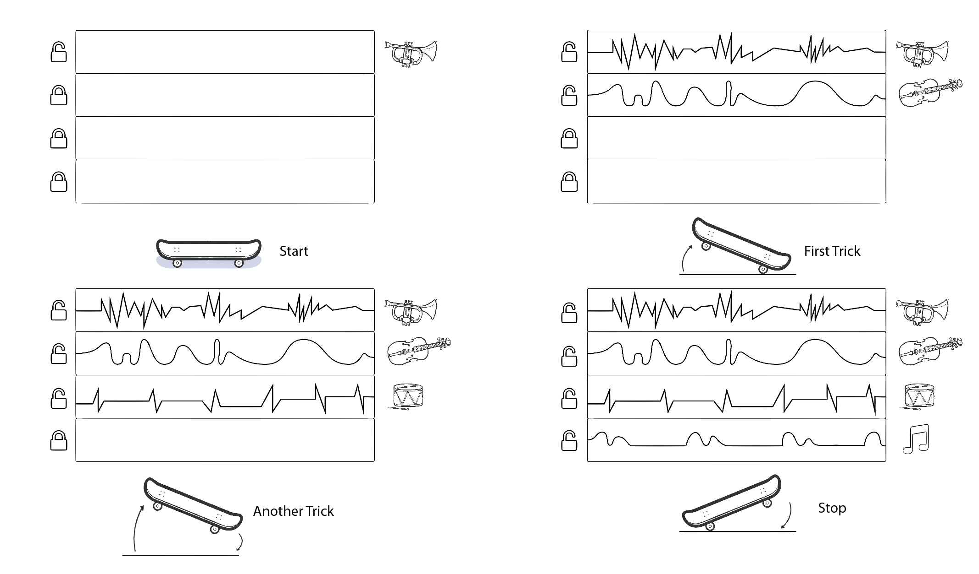 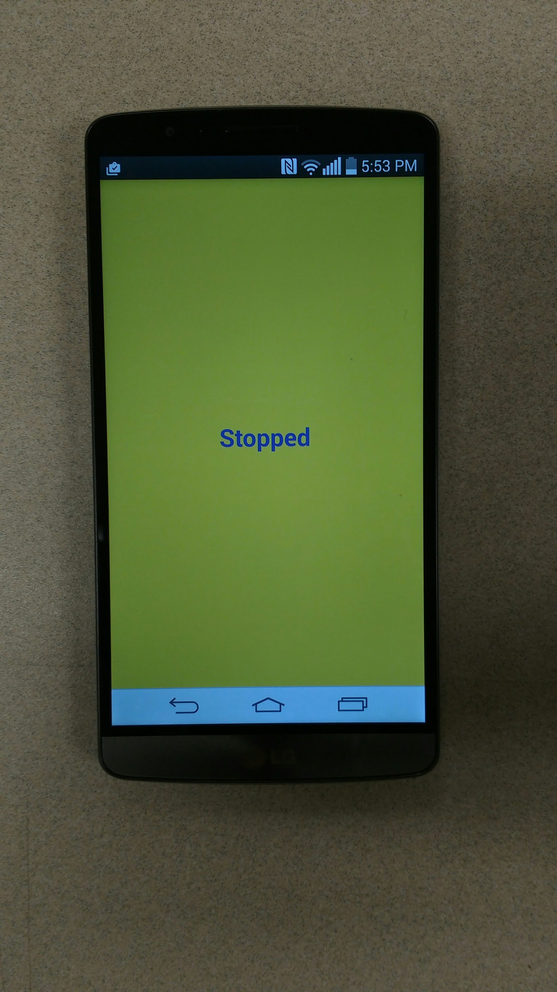

*Left: Concept for Tricks for Tracks. Right: Tricks for Tracks prototype on an Android device.*

1. **Freestyle:** Musical*sound effects* are played to indicate specific movements made by the skater (e.g., ollie, tic-tac). At the moment this system is using audio effects from the video game Super Mario Bros. We used an Arduino USB board for this prototype.

12333676_10206145361646805_214863669_o.jpg

*Freestyle prototype using Arduino*

The following report will be describing the evaluation results for our prototype. This includes the procedure and results of our heuristic evaluation and usability testing sessions, an analysis of our findings and the next steps for further iteration.

# Methodology

There were two stages for evaluating our prototype: the first stage was a heuristic evaluation session conducted by another group from our PSYC 6023 class. Based on these findings, we implemented changes on our prototype and then proceeded with user testing.

## Heuristic Evaluation

We conducted a heuristic evaluation session with another team from our class consisting of Meeshu Agnihotri, David Chiang and Kara Kenna. The purpose of this is to internally evaluate our system for major usability issues before presenting it to the user for testing.

### Description of Methodology

#### Introductions

**Description of activity:** The moderator briefed the participants about the heuristics evaluation activity. She informed them about their role as usability experts and encourages them to ask questions about the interface. She told the experts they are not allowed to communicate with each other about their findings and to list them down either through the paper sheets or the electronic document provided. Both forms had Nielsen’s 10 heuristics as baseline criteria and fields for comments and severity ratings from 0-4 (0 being not an issue and 4 being a severe issue).

**Provide context of the project:** The moderator then explained the MusiSkate concept and its two modes as described in the introduction. She described how they will be primarily evaluating an audio interface, and she gave additional emphasis on the importance of audio feedback for users. Because our group felt that perhaps not all of Nielsen’s heuristics may apply to our prototype, we provided audio-specific heuristics based on the Sonification Handbook [1]:

* Design must have clear and suitable volume.
* Design must match user’s perception when representing data.
* Our design must can be both non-interactive and user-initiated.

**Dividing the session into two groups:** The first evaluator tested the Tricks for Tracks phone prototype, while a second person tested the Freestyle (IMU) prototype. Each person was assigned a facilitator and a notetaker. The remaining expert will be waiting for her turn and can optionally watch videos of our concept for better understanding (<http://www.youtube.com/playlist?list=PLiUzXiAkqpeoJLtWnRYi7MSr-J8gOP6kN>)

#### Task scenarios (~15 minutes per person)

The evaluation started with a briefing by each moderator on the specific motions that can be detected by their assigned prototype. They then showed videos and images to the participants on how these motions are supposed to be performed by skaters. For our evaluators’ safety, we did not ask them to perform these motions on a skateboard but instead do their best to imitate the motions by moving around and flipping the prototypes as necessary[[1]](#footnote-1).

The tasks that were performed by the evaluators are the following:

* Tricks for Tracks
  + Find out the sound for moving forward on skateboard
  + Find out the sound for moving forward and doing an ollie (a jump)[[2]](#footnote-2)
  + Find out the sound for moving forward, doing an ollie. then a kickturn (move prototype to 180 degrees)
  + Freely explore the system

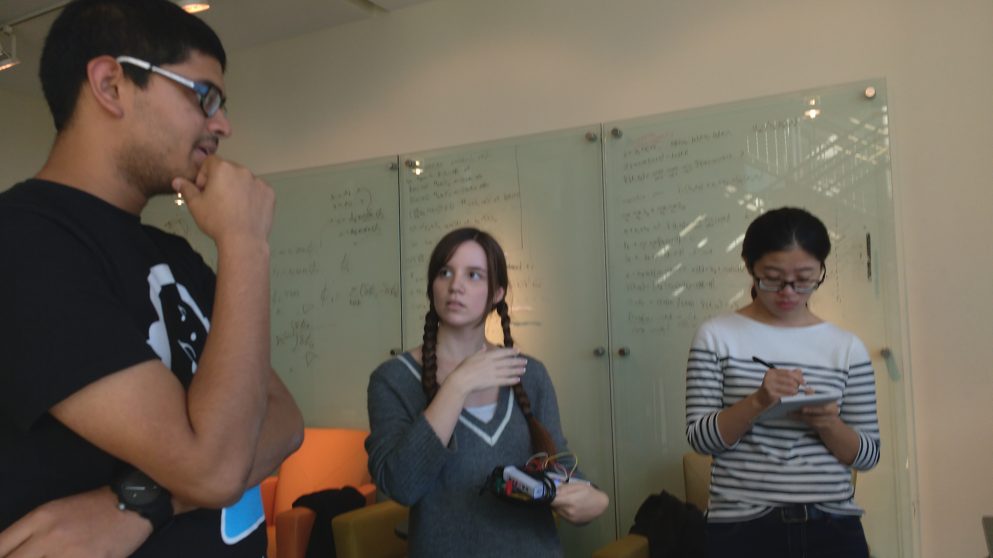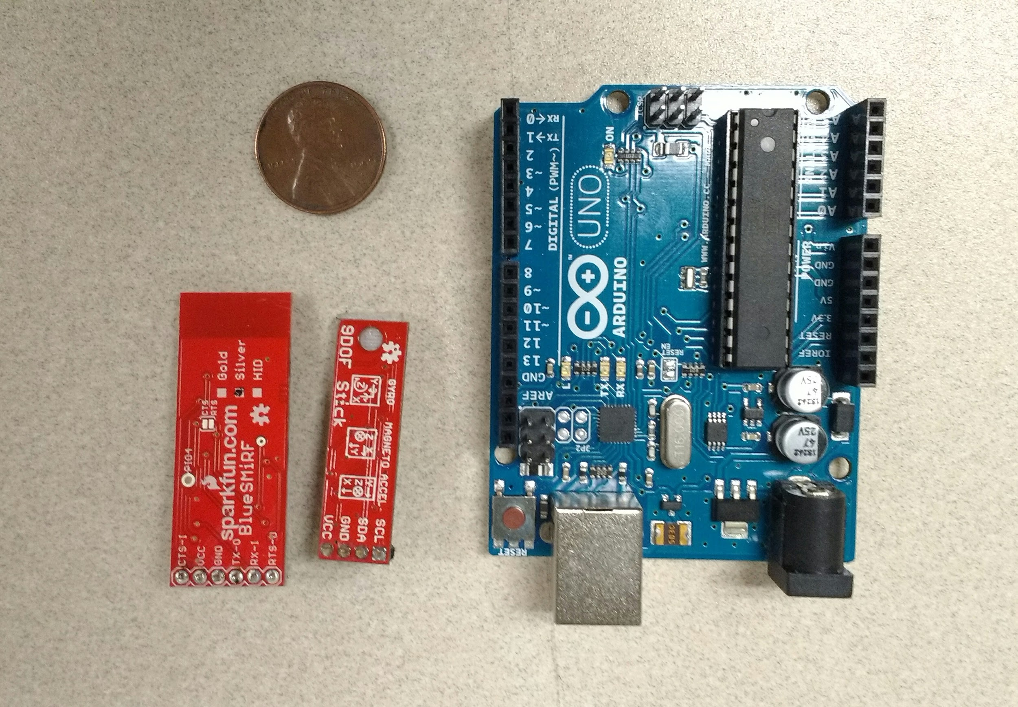

*Freestyle system being tested by our participant. Its version during that time was attached to a breadboard rather than the skateboard.*

* Freestyle
  + Find out the sound for performing an ollie (jump)
  + Find out the sound for doing a tic-tac (zigzagging movement on a skateboard)
  + Freely explore the system

The participants were then allowed to freely explore the audio feedback system. We then had a semi-structured feedback session to elicit the positive and negative points of the system, their thoughts about the feedback and music. The participants then proceeded to a different prototype or recorded their thoughts in the evaluation sheets.

### Rationale for Methodology

Apart from being an assignment for our group, heuristics evaluation had these distinct advantages for our team:

* It’s an easy, fast and cheap way of evaluation. There were no users needed to be recruited, we were able to use the expertise of our classmates to see if there were usability issues in our design that we may have overlooked.
* It helps to define major and minor problems in design through the severity ranking, which was particularly useful for prioritizing design decisions.

The tasks were chosen because of the following reasons:

* The tasks encapsulated all the motions that can be detected by our system.
* Because we were testing an audio interface without any visual cues and because our evaluators were all non-skaters, we had to be specific about the type of tasks they should perform. We also felt such specificity is appropriate because our research interest is to evaluate the audio feedback and its effect on the user’s enjoyment.
* As mentioned earlier we didn’t want to put our evaluators at risk, so we didn’t let them perform tasks on a skateboard. Instead we had them do minimal ground movements.

### Summary of Feedback and Changes Implemented

The following chart describes our main findings from the heuristics evaluation[[3]](#footnote-3) and how it changed our prototype for user testing. In the interest of time, we focused on basic features since we wanted to primarily test how users reacted to the concept of audio feedback while skating. While some of the suggestions may enhance user interaction in the future, we decided to focus first on features that are critical to basic audio feedback and do not require complex trick detection algorithms.

|  |  |  |
| --- | --- | --- |
| Prototype | Feedback | Design Decision |
| Freestyle | Errors, i.e., performing to fail a task must have their own feedback. | Future implementation. The current system does not currently detect tricks or errors, which require performing user motion studies. |
| Reduce feedback delay for unlocking new tracks | Future implementation - using native C code instead of Java for trick detection and changing communications from Bluetooth to Wi-Fi and further algorithm optimizations. |
| Use a better song that has all the tracks (guitars, drums, bass) all playing at once so there will always be feedback once a certain track is activated. | Song was changed from “Boys are Back in Town” by Thin Lizzy into “Learn to Fly” by the Foo Fighters, which had more distinct and continuous individual tracks. |
| Different tracks must be easily distinguishable from each other (e.g., guitar vs. bass layers) to provide clearer feedback |
| Include more “epic” musical feedback for harder tricks | Future implementation will accommodate more complex tricks |
| Tricks for Tracks | Be aware of how the shape, size and the weight of the system may affect the system | To be asked during user testing |
| Customizing their own music | Future implementation |
| A more visible system status | Future implementation |
| Both prototypes | Allow a way to turn on/off the music | Future implementation |

## Usability Testing

We conducted an usability testing of our prototypes with three participants that we recruited. The purpose is to determine whether the prototype work with its intended users and to improve our design. This video demonstrates the testing process:: <https://www.youtube.com/watch?v=k7koih9kIyU&feature=youtu.be>

### Description of Methodology

**Research Question:**

* What is the effect of audio feedback on the satisfaction of performing tricks on skateboards?
* What are the differences between our two prototypes in increasing the satisfaction of skating?

**Threshold of Acceptance:** Prototype must be rated at least 4-5 on the Likert Scale to indicate an enhanced experience.

**Metrics:** We used these metrics for measurement and evaluation:

* Enjoyment
* Usefulness
* Appropriateness
* Meeting of expectations
* Future use

**Participants:**

|  |  |  |  |
| --- | --- | --- | --- |
|  | **P1** | **P2** | **P3** |
| **Age** | 18-24 | 18-24 | 18-24 |
| **Years of skateboarding** | 1-5 years | 1-5 years | 6-10 years |
| **Level of experience** | Intermediate | Intermediate | Intermediate |

We recruited skateboarders we met on the Georgia Tech campus to participate in our test. As undergraduate students, their age ranges all fell under 18-24. Two of them have 1-5 years of skateboarding experience, while one person has 6-10 years. All of them describe themselves as "intermediate" skaters.

Task Scenarios (~60 minutes per person)

**Introduction**

The testing start with a brief introduction by the moderator on the prototypes and the objectives of the research project. After obtaining consent from the participants, then the moderator showed the concept video to the participants to help them understand our design concept (<http://www.youtube.com/playlist?list=PLiUzXiAkqpeoJLtWnRYi7MSr-J8gOP6kN>).

**Pre-test questionnaire**

Before the testing, each participant answered a demographic questionnaire about their skating experience and a concept evaluation questionnaire about their opinions on the concept of both two prototypes. The demographic questionnaire gathers participant’s background and helps to determine whether their skills influence the experience and satisfaction of the prototypes. The pre-test questionnaire sets a baseline for each metric of the concept that we will evaluate, then we will compare the pre-test and post-test questionnaire to find out how much the prototypes enhanced skating experience.

Below are the questions that are included in the concept evaluation questionnaire:

* How much does audio feedback increase the enjoyment of skating? (Satisfaction)
* How useful is the audio feedback? (Usefulness)
* How appropriate was the audio feedback for the different tasks? (Appropriateness)
* How interested are you to use this prototype in the future? (Future use)
* What do you like / dislike about the system?
* How would you improve this system?

**Task**

Each participant is asked to perform tasks on both two prototypes.

1. Prototype A - tricks and tracks

* Move on the skateboard and stop
* Move on the skateboard, perform an ollie, and then stop
* Move on the skateboard, perform an ollie, a kickturn, and then stop

1. Prototype B - freestyle

* Move on the skateboard and do a tic-tac
* Move on the skateboard and do an ollie
* Freestyle (1-3 minutes)

**Post-test questionnaire**

After completing the tasks, participants will do a concept evaluation questionnaire. The questions are same as in pre-test questionnaire.

### Rationale for Methodology

* We did pre-test and post-test questionnaire to find out the increase in user’s satisfaction. The pre-test questionnaire sets a baseline for each metric of the concept that we will evaluate, then we will compare the pre-test and post-test questionnaire data to find out how much the prototypes enhanced user’s skating experience. It also helps to see if the prototypes meets, exceeds or falls short of expectations.
* We combined Likert scale and comments in the metric evaluation because the quantitative data can from the scale enables a precise assessment of our prototypes and provides better support of our findings. And we can prioritize the problems according to severity ratings.
* The reasons for different tasks choosing in different prototypes are various. First, tthe two prototypes focus on different aspects of the concept and have different design scenarios, and we designed the tasks to fit different functions. Second, we selected basic tricks that can be performed by most intermediate skaters and ensure their safety. Finally, we did not have them perform stunts like grinding, which would have damaged the underside of the skateboard and our prototypes.

# Results and Analysis

## Freestyle

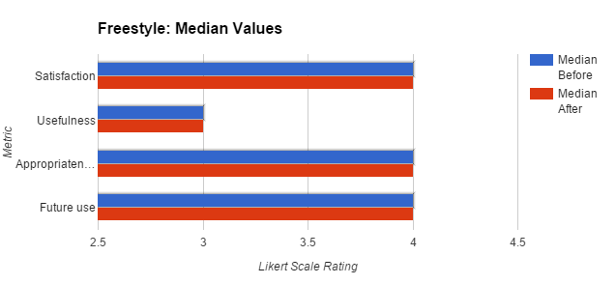

**Satisfaction:** There is no observed change in the satisfaction ranking for Freestyle based on the pre- and post-test evaluations. Based on this data, we can infer that the users felt the prototype met their initial expectations. The prototype was accurate in replicating our initial concept as shown in the video. Moreover, users felt that the immediate feedback adds value to the experience of skateboarding. One user described how the sounds makes him "feel good" after performing a trick, and another adds how it adds to the "fun" factor.

**Usefulness:** On the one hand, participants perceived Freestyle as more "fun" rather than "useful" (median = 3). On the other hand, as mentioned, it is encouraging for participants to get audio confirmation of doing a trick, and it also provides an intrinsic goal for them ("I wanted to hear the sound, so I jumped."). In a sense, having a reward system adds an incentive to learning. Another point that was raised is how audio can also help "muscle memory".

**Appropriateness:** Most participants thought the audio feedback that was provided by the prototype was fitting (median = 4). They felt the musical effects from the video game Mario Bros. was appropriately mapped to their movements. For example, an ollie (jump) would produce a more complex sound with a rising pitch. In spite of this, users also thought there should be more sounds that respond to more challenging tricks. At one point, P1 performed a kickflip, a trick in which the skater flips the board 360 degrees with his feet during a jump. He was disappointed that the musical feedback for that was the same for a kickturn. In skateboarding, there would be tricks that add more flourishes and angular dimensions to basic tricks like the ollie, and he felt the audio effects should accommodate this increasing complexity.

**Future Use:** Participants all thought they may use this prototype because of the fun factor (median = 4). One participant, who is primarily a longboarder, thought he will use it less because he does not normally perform tricks. This is also a consideration for us in future testing - to validate whether the system is satisfying for longboarders as well.

## Tricks for Tracks

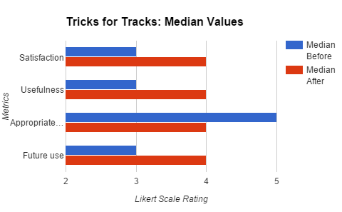

**Satisfaction:** There was an increase in perceived satisfaction after using the Tricks for Tracks prototype (median = 3 to median = 4). The reason for this was a perception of higher rewards and a greater feeling of motivation. One user mentioned how he didn't think tricks for tracks would be as good as freestyle, although he changed his perception later after he has tried it.

**Usefulness:** There was an increase in the perceived usefulness of the prototype (median = 3 to median = 4). The system was useful as a source of encouragement and motivation, especially in its progressive aspect. However, it was noted that it may be more acceptable to line skaters rather than beginners and freestyle-type skaters. Line skaters would typically combine tricks in a sequence, and for some skaters this can be a way of showing off their expertise. Game of Skate, a skateboarding game in which competitors challenge each other to try to land a series of tricks, is another parallel use case in which sequence matters for skaters. Freestyle skaters, as the name implies, tend to do a more random variety of tricks from their arsenal. In addition, two participants mentioned how less advanced skaters would tend to repeat tricks until they get it, and so Tricks for Tracks, with its fixed nature, may be too restrictive for this use case.

**Appropriateness:** Finally, the perceived appropriateness of the music provided decreased but still fell within an acceptable threshold. While the sequence of music was seen as appropriate because of the increasing complexity (drums, guitars and then vocals), the actual song choice received mixed feedback. Some users liked the song because it was fast-paced and popular, but they mentioned the need for personalization and control, especially since most users (n=2) listened to their own music while skating and had unique preferences ranging from punk to electronic dance music. Trick-to-reward mapping also needs to improve, i.e., there should be better audio rewards based on difficulty, and the audio transition for layering on new tracks was too noticeable. Another comment is to have something constantly playing in the background, such as a drum line. One user felt discouraged by the sudden absence of sound when he stops in between performing tricks, which was the opposite intent of our design.

## 

## 

## Overall comparison

|  |  |  |  |
| --- | --- | --- | --- |
|  | **P1** | **P2** | **P3** |
| Preference: Freestyle Vs. Tricks for Tracks | Freestyle | Freestyle | Equally good |

When asked to compare which system they preferred over the other, two participants mentioned they like Freestyle more than Tricks for Tracks. As mentioned earlier, they felt Freestyle is more suitable for their style of skating, i.e., it accommodates repetition and is more flexible. It should be mentioned that the Tricks for Tracks prototype didn't detect tricks accurately for Participant 2, who reacted negatively to it. Because of this, we implemented a Wizard of Oz protocol for P3, which played the sounds manually for each successful trick. This may be the reason why P3 thought both systems were good. Hence, the phone prototype failing to read tricks may have influenced the results of our test and the perception of the system.

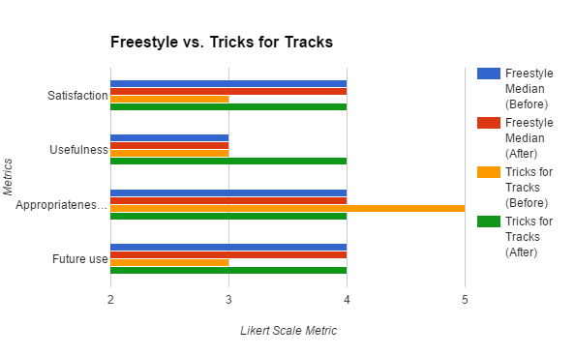

In general, the ratings for Freestyle remained constant for the pre-test and post-test questionnaires, implying that it met the users’ expectations of the system. One thing to note is it did not meet the threshold of 4 for usefulness, which shows that it was perceived to be more entertaining than useful.This can be due to the fact that the Freestyle interaction does not utilize a rewarding methodology but concentrates more on bringing out the creative side of the skater. This creative aspect will become more prominent when a larger number of tricks and movements can be mapped to widely varying sound-effects and also when the user gets the choice of choosing his/her own music track. For Tricks for Tracks, the usefulness and future use increased (median = 4) and decreased in appropriateness (median = 4), which can mean the users felt it exceeded their expectations but the music must be more customizable for their own purposes. Overall, the prototypes met our threshold of acceptance of 4-5 on the Likert Scale.

### Summary

User studies were performed with 3 participants which revealed design issues, some of which need more immediate action

#### Major issues

* Fragile prototypes - As we found out from the data, the performance of the prototypes mattered a lot in the users’ overall perception of the system. Our prototypes need to be made more robust so that they perform at a consistent level throughout every session of study.
* Transferring control to the users- both our prototypes need to be redesigned such that users have more control over the kinds of audio feedback they want to receive. Since the prototypes were hard-coded to use only one track of music and a specific set of sound effects, it does not give us a complete understanding of the usefulness of the system -individual preferences come into the picture and that reflects on the user responses.

#### Minor Issues

* Lag in system response- Prototype implementation needs to be optimized so that the timing of the audio feedback can be perfected. Users must not need to wait after performing a trick to receive the suitable feedback.
* Not enough tricks identified- if the system is improved to identify and respond to a wider variety of tricks, it can bring out the creative side of a skater and thus change the perception of the system altogether.

#### Positive Take-Aways

Despite the design issues, the system received an overall positive response from all the participants. They confirmed the fact that many skaters like to listen to music while skating and using the skateboard itself to generate sound and control music was perceived as a really “cool” and motivational idea. All the participants felt eager to try out the product in future and felt that audio feedback is highly suitable for skateboarding in general. Our design includes two different modes of interaction Freestyle and Tricks for Tracks, and both the modes of interaction seemed to address different aspects of the skateboarding experience- Freestyle can be used in earlier stages of skateboarding when skaters need to practice the same trick repeatedly whereas Tricks for Tracks can be useful once they have gained mastery over a set of tricks. Moreover while Freestyle was perceived as more fun and creative, Tricks for Tracks was perceived as more rewarding and useful. Tricks for Tracks surprised the users in terms of satisfaction as is seen from the differences in the pre and post questionnaire results. Freestyle on the other hand remained more or less constant and kept up to the expectations of the users as expressed in the pre-test questionnaire.

#### Other Comments

Users also mentioned how they have their own preferences for their skateboards and gear in general. One user felt that the trucks on our skateboard are “too tight”, and spent some time to adjust to it. This prompts us to explore ways to to latch the sensors to any type of skateboard in the future. In addition, one participant suggested adding a “gamified” component to our system through point systems for tricks, leaderboards and more complex musical feedback.

# Rationale for Analysis methods

## Quantitative Analysis

Users were asked 4 likert scale questions before and after the test sessions. Each question had a scale from 1-5 ( completely disagree-completely agree).Questions were asked before each session to judge the users’ perception of the concept that was explained verbally and through video demonstrations. The same questions were asked after each session to see how the perception of the system changed after having used it. This helped us judge how the perception changes depending on the performance of our prototypes.

The data collected were all likert scale rating values- which is ordinal data. Thus we found the median of the values to present our conclusions from the data.

Although we received valuable insights into how to make our prototypes work better and what factors should be changed, the data was collected from only 3 participants. Due to this limitation we cannot claim statistical significance of the results obtained, although they are surely good enough to initiate our design iteration.

## Qualitative analysis

A similar procedure of pre and post test questionnaires was used for the qualitative analysis. .This played an important part in understanding what prompted the users to give the ratings that they provided in the quantitative questions. The whole session was also video-recorded and later annotated,, which led to the creation of mind-maps. These maps were then used for drawing the conclusions from the data as presented above.

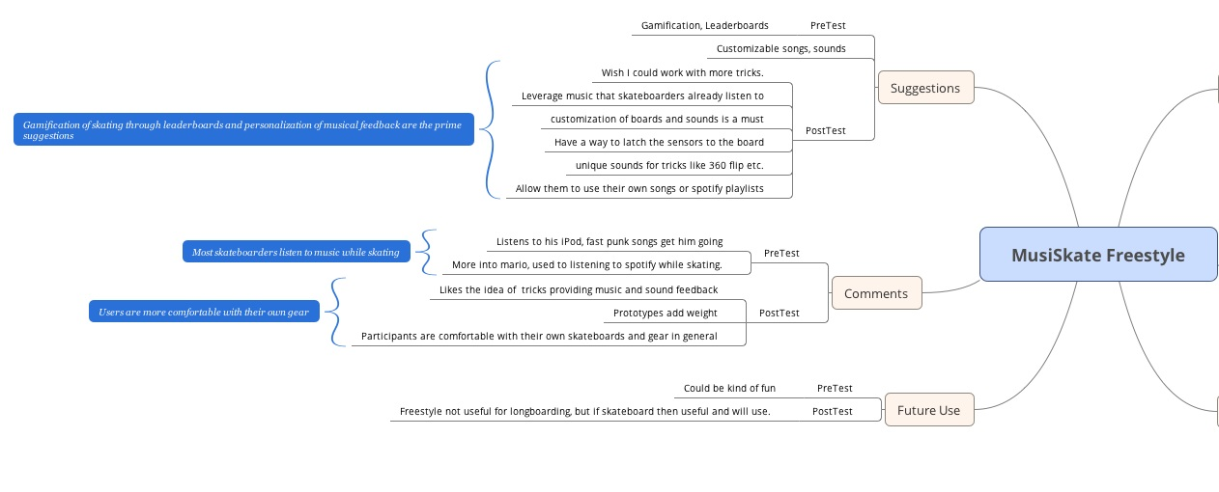

Left half of mindmap for Freestyle Interaction

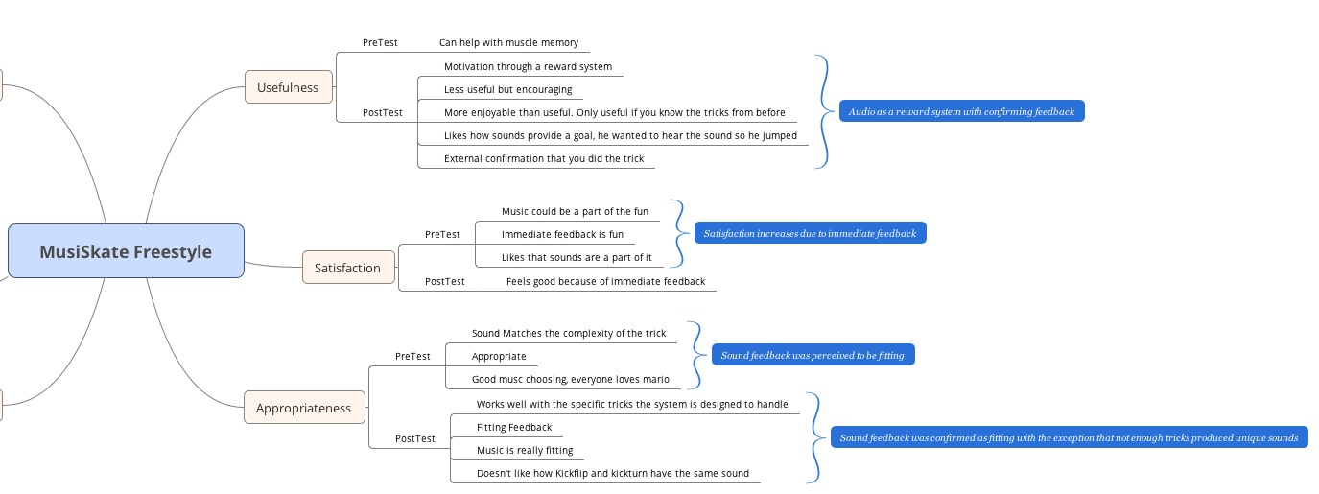

Right half of mindmap for Freestyle Interaction

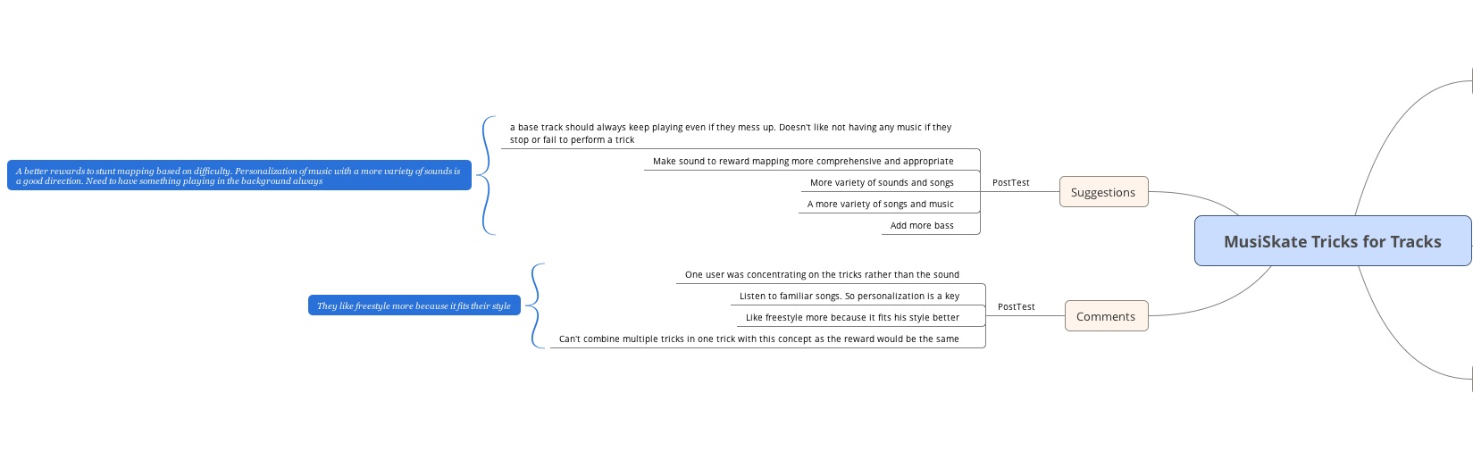

Left Half of Mindmap for Tricks for Tracks

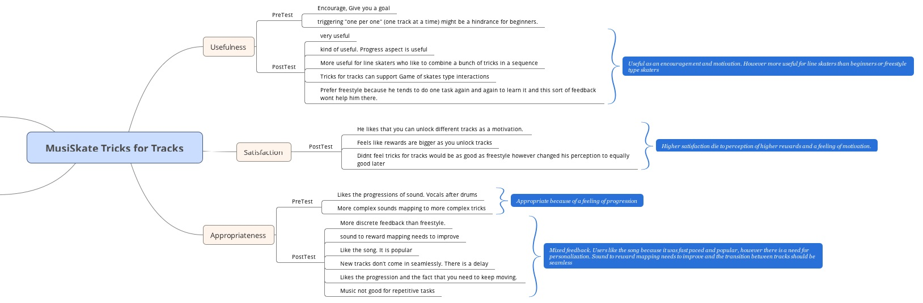

Right half of Mindmap for Tricks for Tracks

# Design Changes

Based on the usability tests and the data we received from the evaluation plans, there are quite a few things that we would like to change with our prototypes. Even though the end goal is to combine both prototypes in a cohesive system we will be discussing the changes with respect to each prototype to make sure we cover all aspects.

## Tricks for Tracks

This system was evaluated using the Android App prototype on the phone attached to skateboard. The various aspects that we would change or do differently are mentioned below

### Hardware

Attaching a phone to the bottom of the prototype is not a long term solution. It was fine for the purposes of our evaluation testing to just strap the phone to bottom of the skateboard using duct tape, however that too had its own problems.

#### Problem

Phone screen was facing the board, hence we could not interact with it directly. The problems faced due to this design are mentioned below.

* This was a major problem when we wanted to reset the bluetooth when there was a loss of connection between the phone and the speakers and even when we wanted to just load new versions of the app onto the phone.
* Every time we had to remove the duct tape, do the things required and strap the phone again with duct tape.
* This led to loss of time during testing, time during which the users had to be kept waiting.

#### Solution

We would change the architecture of this prototype to have sensors enclosed in a small case attached to the bottom of the board. These sensors would be paired to a phone via that the user can carry with them in their pockets. This sort of architecture can support a long term goal of having a smart board without having to take the risk of strapping one’s phone to it. Also this sort of an architecture would have helped us avoid the problems that came with not being able to interact with the phone when the phone was strapped to the board.

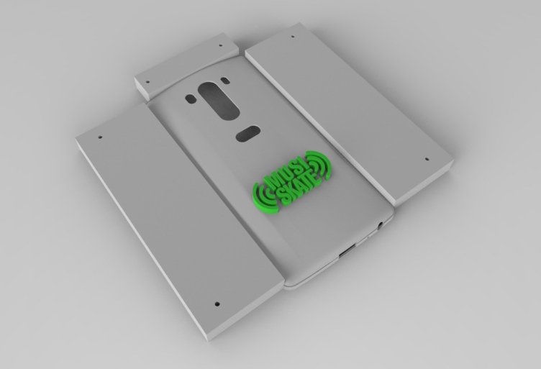

*3D model of a proposed case to be attached to a the skateboard. This was not implemented due to time constraints.*

### Software

The majority of our design isn’t visual but based on the software proficiency in detecting a particular trick or stunt and the sound feedback provided for the detected trick and stunt. Based on our observations during the study combined with the feedback we received from our participants our sound choices were pretty good, however there is quite a great deal I would change with the software.

The current software design for the Android App is using fuzzy logic and hand tested threshold values. The data received from the phone sensors is run through the algorithm that allows fuzzy data and compared with the threshold values to classify what sort of a trick was detected.

We went with this design for detection of tricks because we did not have any data on the kind of sensor data generated for these tricks and since none of us skateboard we could not test run the system to generate that data and refine the prototype. Also time and pending IRB approval to run user tests were added constraints on collecting the data that we required for classification of the tricks. We did try and contact other industry professional to receive related data which we could use. We finally did get the data, however, by the time we received the data we were already on the verge of starting user testing.

#### Problem

1. Due to the fuzzy interpretation of sensor data the trick detection is not always accurate. The user had to perform the tricks a couple of the times before the system could detect it properly and even then it wasn’t as efficient and immediate as we would have liked it to be.
2. Due to fuzzy interpretation of sensor data we had to make sure the tricks we detected on the phone for tricks for tracks were simple and distinct enough that we wouldn’t run into false positive detections for the different tricks. This limited our capability to test the prototype with a range of stunts.

#### Solution

The long term and comprehensive solution for this problem would be to use the sensor data we have collected for different tricks in our usability study combined with the skateboard motion data we received from a fellow researcher Benjamin Groh from Friedrich-Alexander University Erlangen-Nürnberg (FAU) and use this with a supervised machine learning algorithm to build a neural net that can then be used to classify the tasks in real-time with the sensor data generated through the sensors attached to the board. This way we could map tracks to tricks and detect using this neural network and provide a better reward mechanisms based on the difficulty of the tricks performed

### Future work

In general the future work for the “Tricks for Tracks” concept includes the following:

1. Fixing the hardware and software issues mentioned above
2. Providing a feature for using custom songs, either with the Spotify playlists or with user’s playlists for the trick unlocking feature.
3. Design and implement a better reward structure based on the difficulty of the tasks rather than just unlocking the track no matter how complex the stunt performed.
4. Furthermore reward structure should include enhancing sound feedback like enforcing the bass or guitar etc in the user chosen songs and possibly even providing high reward features like a a 30 sec jam track unlock for complex sequences of stunts.

## Freestyle

This system was evaluated using the an Arduino Uno and a couple of sensors namely, a Bluetooth module ([BlueSmirf silver](https://www.sparkfun.com/products/12577)) and a 9DOF IMU Stick ([Sparkfun Sensor Stick](https://www.sparkfun.com/products/10724)), which were connected together and stuck on the underside of the skateboard using duct-tape.

### Hardware

The bluetooth and the IMU sensor were soldered to a prototype PCB.. Pins were added to the PCB such that it fits perfectly on an Arduino Uno. The Arduino Uno was powered by a 9V battery using an adapter connection. The arduino assembly and the battery were then strapped onto the underside of the skateboard, near to to wheels on one side. it did not matter which set of wheels it was near to.

#### Problems

* No additional power switch were added - every time we wanted to turn off the system, we had to cut off the connection to the battery.
* Prototyping wires and amateur soldering could not handle the immense amount of collisions that the skateboard went through. After every user testing session, the prototype had to be removed and resoldered to make it ready for the next session.
* Although the system was designed to trigger an audio response in the middle of a trick performance, we noticed a significant lag in getting the response in comparison to the time it took for completing a trick.
* The arduino was paired to a computer using the bluetooth and the sounds were played using speakers which were in turn paired with the computer. Sometimes, due to the ambient noise, the sound effects could not be heard clearly by the participants, when they were away from the speakers.

#### Potential Solutions

* The PCB board should have a small on/off button. Once we shift our design from a prototype PCB to an embedded PCB, a small button can be added.
* An embedded PCB must be designed to house the micro-controller as well as the sensors. We can get rid of the Arduino Uno and go for a much smaller micro-controller. The PCB can be designed to include battery connections as well, that way we can really optimize our hardware dimensions and capabilities. It might also be interesting to use the product called [Syrmo](http://syrmo.com/)  which comes with a sensor and an app to sense skateboard performance metrics. This product is currently not on the market yet. However if we can get access to it, it will be interesting to see how we can integrate our system on top of the Syrmo app and hardware.
* On the hardware side, lag can be handled using
  + sensors with higher sampling rates
  + a faster microcontroller than that in Arduino Uno.
  + Bluetooth modules that can handle data transfer at high baud rates like 57600 bps
  + Trying to connect the sensor using WiFI to a phone, rather than a bluetooth connection
* The system can be developed to pair with an app on a mobile phone, which the user can carry while skating. Thus the source of sound will always be near to the skater.

### Software

The software was built using Arduino IDE and Processing IDE. We used the open source [AHRS](https://github.com/ptrbrtz/razor-9dof-ahrs) firmware for arduino to gather data from the IMU sensor and to convert them into yaw, pitch and roll angles. We optimized the code to suit our purposes and to send the angles through a bluetooth to the computer, that was running a processing sketch. On the processing side we used serial events to capture the data coming in from the arduino and then processed the data to understand what kind of tricks were being performed. Suitable sound clips were then played using the [Minim](http://code.compartmental.net/tools/minim/) Library of Processing.

#### Problem

* Non customizable- The sounds for the audio feedback were hard-coded and the only song that was used as the background music was the Mario Brothers theme. There was no option of using personal music tracks.
* Limited number of tricks supported- For the purposes of the user test, we were detecting only 3-4 tricks that had significantly different movements. However, when the users tried to perform more complicated movements, the system response was not suitable anymore.
* There was a lag in the audio response such that the sound clips could only be heard only after the trick was already performed. The original intention was to provide audio feedback while tricks were still being performed.
* No way of keeping track of performance. Although the prototype aimed at bringing out the creative side of skaters such that they can add personal touches on top of a bass track of music, there were no methods of keeping track of individual performances for future reflections.

#### Potential Solutions

* Pairing the sensors to a mobile phone app could potentially solve the problem of being able to select personal tracks while skating. The mobile phone app could accommodate a personal playlist on which the user can add effects by performing tricks. However a bigger and much more difficult question is how can we build a system such that it can modify the sound effects according to the song-tracks being played at the moment. The sound effects that we use currently are suitable for the mario track which is hard-coded. But once the user gets the power to change the Mario track to something else, the system must be able to apply suitable sound effects. This problem is still under consideration.
* Instead of mapping skateboard twists and turns to sound effects, we can map the complexity of tricks to sound effects that indicate the complexity of the tricks. This can be a potential new research direction.
* Optimizing the code in order to reduce data processing time can reduce the lag perceived in receiving audio response. The current code expects the arduino to send data in the form of strings which means excess bytes are being transferred. Data transmission in binary coded form can reduce the transmission time as well.
* There should be an option of recording the audio being outputted ( including the base tracks and the sound effects added on top ) so that the user can reflect back and replay the composite track.

### Future work

In general the future work for the “Freestyle” concept includes the following:

* Making the hardware more robust and suitable for rough usage.
* Getting rid of the lag in receiving audio feedback
* Giving more control to users so that they can select their own music and the kind of feedback they want to receive.
* Combining both the modes of interaction “Freestyle” and “Tricks for Tracks” into a single phone based prototype- sensors on the skateboard will be paired with a phone and depending on the user’s choice he/she will be able to choose either of the two forms of interactions.
* Developing a system of recording the performance so that users can hear and reflect on their performance later on and can also compare with friends. A quick and interesting method can be generating short guitar licks, associating them with different tricks and adding them on any base track that the user wants to listen to. The system would then keep on recording the output audio.
* Enabling Collaborative jamming between skaters in a way that every skateboard can be mapped to different timbres or tones and together they can generate a composite track.

# Final Words

In sum, with our MusiSkate prototype, we have demonstrated how audio feedback can play a part in enhancing the experience of skateboarding and potentially being useful in long-term learning of tricks. These findings suggest applications in other trick-based sports. Future iterations will include a combination the two prototypes, finer trick detection algorithms, increasing the complexity of the reward structure and customization of musical and skateboard preferences.

# Appendix 1 - Usability Study Script

# Objectives

## Research Questions

1. What is the effect of audio feedback on the satisfaction of performing tricks on skateboards?
2. What are the differences between our two prototypes in increasing the satisfaction of skating?

## Independent variables

1. Guided learning prototype (song)
2. Freestyle learning prototype (sound effects)

## Metrics:

* Enjoyment
* Usefulness
* Appropriateness
* Meeting of expectations
* Future use

## Threshold of Acceptance on the Likert Scale: 4-5

## Roles

|  |  |  |  |
| --- | --- | --- | --- |
|  | P1 | P2 | P3 |
| Facilitator | Lori | Lori | Lori |
| Notes | Ivy | Ivy | Ivy |
| Photos/Video | Tripod Recording | Tripod Recording | Pratik |
| Troubleshooting | Pratik/Sarthak | Pratik/Sarthak | Sarthak |

# Introductions (5 minutes)

**Moderator:**

Thanks for coming in today! We are master’s students studying Human-Computer Interaction at Georgia Tech. [Introduce various members]

As part of our class project for CS 8803, my group has developed a prototype called MusiSkate, which plays musical feedback to skateboard movements. Our goal is to determine whether our prototype increases a user’s satisfaction of skateboarding and encourages skaters to keep practicing.

For the test you will be performing a series of skateboarding-related tasks with our prototype. We will then ask questions relating to your experience. The whole session will last for about an hour, but it’s possible that it’s going to be less than that.

Before we start, I need to ask you to sign this consent form required to us by Georgia Tech. I’d like to highlight two parts of this. First, it’s a reminder that our conversations today will be strictly confidential and will only be used for this study. Second, it also gets your permission for me to record our session for our internal use. That way we can go back and review it later. And, of course, you’re free to take a break or leave at any time during the session. The last thing is we are required to have you wear your helmet, wrist pads, gloves, knee pads and elbow pads. Ideally we would like you to wear whatever you wish, but Georgia Tech is very strict with participant safety.

**[Hand consent to participant with pen to sign.]**

Please take your time reviewing this and let me know if you have any questions

**[If person is a minor and the parent is around]** We also need you to sign this to ask for permission to allow your child to participate in our study.

**[If person is a minor and the parent isn’t around]** Since you’re under 18, we also need your parent/guardian to sign this for us for legal reasons. You can just take a photo and send it to us through email.

**[After Consent is signed, notetaker, start recording.]**

We’d like to keep this session informal. I’m just trying to learn from you today. I’ll ask a lot of questions, but this is not a test. There are no right or wrong answers.

I’ll start this session by asking some background questions. Then I’ll show you the things we’re working on, and ask you to do some tasks.

After you’ve finished the tasks, we’d like you to tell us your thoughts about how it went, what you liked or didn’t like about it. This will all help us develop a better prototype in the future, so we’d like your honest opinion.

Do you have any questions before we begin?

# Demographic Questionnaire

To begin I’d like to ask you some questions about your skating experience. If you’ve already answered this we won’t do it again.

**[Worksheet: Demographic Questionnaire]**

# Concept Discussions

Thanks for sharing about your background in skating. We’d now like to show you the prototypes we mentioned earlier and get your feedback. Since these are prototypes, it means they’re not going to be perfect and polished. **[show them the prototype]**

## Prototype A: Tricks for Tracks

The first prototype is a phone app that uses the sensors on the phone to detect the movement performed by the skater. There is a sequence of tricks you have to perform - every time you perform a trick successfully it unlocks a different track inside a song. For example, the first trick unlocks the drums in a song then another to unlock the guitar track and so on and so forth.

**Show video demo:** [**https://youtu.be/2LoAFsnLgEY?=52st**](https://youtu.be/2LoAFsnLgEY?t=52s)

I’d like to know what are your first impressions are about this concept. **[Bring out concept evaluation form - Tricks for Tracks]**

## Prototype B: Freestyle

**[Explain main features of Prototype B]**

This prototype utilises an IMU sensor to gather data about the skateboard’s movement and gives real-time audio feedback about an action. This data is then processed using an arduino and sent to a computer. The computer interprets the processed data and generates sound that serves as suitable feedback for the performed movement.

**Show video demo:**  <https://youtu.be/2LoAFsnLgEY>

I’d like to know what are your impressions about this concept. These would be the same questions as before. **[Bring out concept evaluation form - Freestyle]**

# Testing

For this part, you will be performing specific tricks with both prototypes and then give us your feedback about the experience. We will ask you to perform a set of tasks, and you will perform this about three times. You will start the task on this line on the floor here and up to that area there and then go back to us. You can keep attempting the task until you get it right, or until you’d like to move on to the next one.

Before we start we are required to tell you to remove any items from your pocket - cellphone, keys, wallet. We will return your items back to you once you are done with the task. Next we are also required to have you wear the safety gear as we explained in the beginning.

Do you have any questions before we begin?

## Prototype A: Tricks for Tracks

Here are the list of tasks you are required to perform:

**[Show participants Task List A - Tricks for Tracks]**

1. Move on the skateboard and stop
2. Move on the skateboard, perform an ollie and then stop
3. Move on the skateboard, perform an ollie, and then a kickturn, and then stop

You may begin when you’re ready.

Thanks for performing all those tricks. Feel free to grab a drink while we ask you some questions about your experience. **[Worksheet 1 - Tricks for Tracks]**

## Prototype B: Freestyle

For the next prototype, here are the two tricks you are required to perform:

**[Show participants Task List B - Freestyle]**

1. Move on the skateboard and do a tic-tac
2. Move on the skateboard and do an ollie

Again we’d like you to do each task 3 times. After that, because we also would like you to explore the skateboard and do tricks as you would normally would. Kickflip and kickturn would be in theory supported.

1. Freestyle (1-3 minutes)

Now we’d like to ask you what you think about that prototype. **[Worksheet 2 - Freestyle]**

# Wrap Up and Cool Down (5 minutes)

This has been incredibly helpful for us.

[Moderator: Try to briefly summarize some key parts of the discussion or issues.]

Your input is really valuable for me and the team as we try to refine our ideas. We really appreciate your taking the time to come in, and answering all of my questions. Thank you so much.

# [DON’T stop recording or screensharing until after participant has left!!]

# 

# Appendix 2 - Evaluation Forms for Usability Study

# 

# Demographic Questionnaire

Name \_\_\_\_\_\_\_\_\_\_\_\_\_\_\_\_\_\_\_\_\_\_\_\_\_\_\_\_\_\_

Contact number \_\_\_\_\_\_\_\_\_\_\_\_\_\_\_\_\_\_\_\_\_\_\_\_\_\_\_\_\_\_

Email address \_\_\_\_\_\_\_\_\_\_\_\_\_\_\_\_\_\_\_\_\_\_\_\_\_\_\_\_\_\_

Age

* 12 and below
* 12-17
* 18-24
* 25-29
* 30-34
* 35-39
* 40-44
* 45-49
* 50 and above
* Prefer not to answer

How long have you been skateboarding? \*

* Less than 1 year
* 1-5 years
* 6-10 years
* More than 10 years

How would you describe your level of experience in skating?

* Beginner
* Intermediate
* Expert

Worksheet A: Concept Evaluation

Tricks for Tracks

**Please answer the following questions from a scale of 1-5 (1 - Not At All, 5 - A Lot)**

|  |  |  |  |  |  |
| --- | --- | --- | --- | --- | --- |
| **Scale** | **1**  **Not At All** | **2**  **Not Much** | **3**  **A Little** | **4**  **Some** | **5**  **A Lot** |
| How much does audio feedback increase the enjoyment of skating? |  |  |  |  |  |
| How useful is the audio feedback? |  |  |  |  |  |
| How appropriate was the audio feedback for the different tasks? |  |  |  |  |  |
| How interested are you to use this prototype in the future? |  |  |  |  |  |

**Please answer these questions:**

1. What do you like / dislike about the system?

\_\_\_\_\_\_\_\_\_\_\_\_\_\_\_\_\_\_\_\_\_\_\_\_\_\_\_\_\_\_\_\_\_\_\_\_\_\_\_\_\_\_\_\_\_\_\_\_\_\_\_\_\_\_\_\_\_\_\_\_\_\_\_\_\_\_\_\_\_\_\_\_\_\_\_\_\_\_\_\_\_\_\_\_\_\_\_\_\_\_\_\_\_\_\_\_\_\_\_\_\_\_\_\_\_\_\_\_\_\_\_\_\_\_\_\_\_\_\_\_\_\_\_\_\_\_\_\_\_\_\_\_\_\_\_\_\_\_

1. How would you improve this system?

\_\_\_\_\_\_\_\_\_\_\_\_\_\_\_\_\_\_\_\_\_\_\_\_\_\_\_\_\_\_\_\_\_\_\_\_\_\_\_\_\_\_\_\_\_\_\_\_\_\_\_\_\_\_\_\_\_\_\_\_\_\_\_\_\_\_\_\_\_\_\_\_\_\_\_\_\_\_\_\_\_\_\_\_\_\_\_\_\_\_\_\_\_\_\_\_\_\_\_\_\_\_\_\_\_\_\_\_\_\_\_\_\_\_\_\_\_\_\_\_\_\_\_\_\_\_\_\_\_\_\_\_\_\_\_\_\_\_

Worksheet A: Concept Evaluation

Freestyle

**Please answer the following questions from a scale of 1-5 (1 - Not At All, 5 - A Lot)**

|  |  |  |  |  |  |
| --- | --- | --- | --- | --- | --- |
| **Scale** | **1**  **Not At All** | **2**  **Not Much** | **3**  **A Little** | **4**  **Some** | **5**  **A Lot** |
| How much does audio feedback increase the enjoyment of skating? |  |  |  |  |  |
| How useful is the audio feedback? |  |  |  |  |  |
| How appropriate was the audio feedback for the different tasks? |  |  |  |  |  |
| How interested are you to use this prototype in the future? |  |  |  |  |  |

**Please answer these questions:**

1. What do you like / dislike about the system?

\_\_\_\_\_\_\_\_\_\_\_\_\_\_\_\_\_\_\_\_\_\_\_\_\_\_\_\_\_\_\_\_\_\_\_\_\_\_\_\_\_\_\_\_\_\_\_\_\_\_\_\_\_\_\_\_\_\_\_\_\_\_\_\_\_\_\_\_\_\_\_\_\_\_\_\_\_\_\_\_\_\_\_\_\_\_\_\_\_\_\_\_\_\_\_\_\_\_\_\_\_\_\_\_\_\_\_\_\_\_\_\_\_\_\_\_\_\_\_\_\_\_\_\_\_\_\_\_\_\_\_\_\_\_\_\_\_\_

1. How would you improve this system?

\_\_\_\_\_\_\_\_\_\_\_\_\_\_\_\_\_\_\_\_\_\_\_\_\_\_\_\_\_\_\_\_\_\_\_\_\_\_\_\_\_\_\_\_\_\_\_\_\_\_\_\_\_\_\_\_\_\_\_\_\_\_\_\_\_\_\_\_\_\_\_\_\_\_\_\_\_\_\_\_\_\_\_\_\_\_\_\_\_\_\_\_\_\_\_\_\_\_\_\_\_\_\_\_\_\_\_\_\_\_\_\_\_\_\_\_\_\_\_\_\_\_\_\_\_\_\_\_\_\_\_\_\_\_\_\_\_\_

Worksheet B: Post-Task Evaluation

Tricks for Tracks

**Please answer the following questions from a scale of 1-5 (1 - Not At All, 5 - A Lot)**

|  |  |  |  |  |  |
| --- | --- | --- | --- | --- | --- |
| **Scale** | **1**  **Not At All** | **2**  **Not Much** | **3**  **A Little** | **4**  **Some** | **5**  **A Lot** |
| How much does audio feedback increase the enjoyment of skating? |  |  |  |  |  |
| How useful is the audio feedback? |  |  |  |  |  |
| How appropriate was the audio feedback for the different tasks? |  |  |  |  |  |
| How interested are you to use this prototype in the future? |  |  |  |  |  |

**Please answer these questions:**

1. What do you like / dislike about the system?

\_\_\_\_\_\_\_\_\_\_\_\_\_\_\_\_\_\_\_\_\_\_\_\_\_\_\_\_\_\_\_\_\_\_\_\_\_\_\_\_\_\_\_\_\_\_\_\_\_\_\_\_\_\_\_\_\_\_\_\_\_\_\_\_\_\_\_\_\_\_\_\_\_\_\_\_\_\_\_\_\_\_\_\_\_\_\_\_\_\_\_\_\_\_\_\_\_\_\_\_\_\_\_\_\_\_\_\_\_\_\_\_\_\_\_\_\_\_\_\_\_\_\_\_\_\_\_\_\_\_\_\_\_\_\_\_\_\_

1. How would you improve this system?

\_\_\_\_\_\_\_\_\_\_\_\_\_\_\_\_\_\_\_\_\_\_\_\_\_\_\_\_\_\_\_\_\_\_\_\_\_\_\_\_\_\_\_\_\_\_\_\_\_\_\_\_\_\_\_\_\_\_\_\_\_\_\_\_\_\_\_\_\_\_\_\_\_\_\_\_\_\_\_\_\_\_\_\_\_\_\_\_\_\_\_\_\_\_\_\_\_\_\_\_\_\_\_\_\_\_\_\_\_\_\_\_\_\_\_\_\_\_\_\_\_\_\_\_\_\_\_\_\_\_\_\_\_\_\_\_\_\_

Worksheet B: Post-Task Evaluation

Freestyle

**Please answer the following questions from a scale of 1-5 (1 - Not At All, 5 - A Lot)**

|  |  |  |  |  |  |
| --- | --- | --- | --- | --- | --- |
| **Scale** | **1**  **Not At All** | **2**  **Not Much** | **3**  **A Little** | **4**  **Some** | **5**  **A Lot** |
| How much does audio feedback increase the enjoyment of skating? |  |  |  |  |  |
| How useful is the audio feedback? |  |  |  |  |  |
| How appropriate was the audio feedback for the different tasks? |  |  |  |  |  |
| How interested are you to use this prototype in the future? |  |  |  |  |  |

**Please answer these questions:**

1. What do you like / dislike about the system?

\_\_\_\_\_\_\_\_\_\_\_\_\_\_\_\_\_\_\_\_\_\_\_\_\_\_\_\_\_\_\_\_\_\_\_\_\_\_\_\_\_\_\_\_\_\_\_\_\_\_\_\_\_\_\_\_\_\_\_\_\_\_\_\_\_\_\_\_\_\_\_\_\_\_\_\_\_\_\_\_\_\_\_\_\_\_\_\_\_\_\_\_\_\_\_\_\_\_\_\_\_\_\_\_\_\_\_\_\_\_\_\_\_\_\_\_\_\_\_\_\_\_\_\_\_\_\_\_\_\_\_\_\_\_\_\_\_\_

1. How would you improve this system?

\_\_\_\_\_\_\_\_\_\_\_\_\_\_\_\_\_\_\_\_\_\_\_\_\_\_\_\_\_\_\_\_\_\_\_\_\_\_\_\_\_\_\_\_\_\_\_\_\_\_\_\_\_\_\_\_\_\_\_\_\_\_\_\_\_\_\_\_\_\_\_\_\_\_\_\_\_\_\_\_\_\_\_\_\_\_\_\_\_\_\_\_\_\_\_\_\_\_\_\_\_\_\_\_\_\_\_\_\_\_\_\_\_\_\_\_\_\_\_\_\_\_\_\_\_\_\_\_\_\_\_\_\_\_\_\_\_\_

SKATEBOARD

USABILITY TEST ONGOING

Please do not disturb

Task List A - Tricks for Tracks

Here are the list of tasks you are required to perform:

1. **Move on** the skateboard and **stop**
2. **Move on** the skateboard, perform an **ollie**, and then **stop**
3. **Move on** the skateboard, perform an **ollie**, a **kickturn**, and then **stop**

You may begin when you’re ready.

Task List B - Freestyle

Here are the list of tasks you are required to perform:

1. **Move on** the skateboard and do a **tic-tac**
2. **Move on** the skateboard and do an **ollie**
3. **Freestyle** (1-3 minutes)

You may begin when you’re ready.

# 

# Appendix 3 - Screener Questions for the Usability Study

This is an online Google Form available here:

<https://docs.google.com/forms/d/1Xn6jFVouSUKy8XMZ1aIj6QrVUzlMT-XbuaXXLYdWd6s/edit?usp=drive_web>

# Bibliography

[1] S. Pijnappel and F. Mueller, “Copy paste skate,” *CHI '13 Extended Abstracts on Human Factors in Computing Systems on - CHI EA '13*, 2013.

[2] T. Seifert and C. Hedderson, “Intrinsic Motivation and Flow in Skateboarding: An Ethnographic Study,” *Journal of Happiness Studies J Happiness Stud*, vol. 11, no. 3, pp. 277–292, 2009.

[3]

1. Here’s an example of how the tasks were performed on the Freestyle prototype: <https://www.dropbox.com/s/gx6fzt1rt2en8i0/2015-11-12%2019.46.29.mp4?dl=0> [↑](#footnote-ref-1)
2. Ollie demo <http://giphy.com/gifs/flat-ollie-olly-ggrJDm9fJCRG0> [↑](#footnote-ref-2)
3. For more detailed findings of the Heuristics Evaluation, the link to the report can be found here: <https://docs.google.com/document/d/1yCW7q3ZnHEIZJQqMR9Ozb_vA9Mj0g1E642GqRJjTC2o/edit?usp=sharing>

   [↑](#footnote-ref-3)